Practical-4: Basic Programs using Structure and Union
1) | Create, declare and initialize structure employee.
 | Program :-
#include<stdio.h>
struct Employee
{
int Emp_ID;
char Emp_Name[50];
int Emp_Age;
char Emp_Department[20];
float Emp_Salary;
};

void main(){
struct Employee E1={1,"John Doe", 25, "IT", 25000.00};
struct Employee E2;

printf("Enter Employee details \n");
E2.Emp_ID=2;
printf("Enter Name:");
scanf("%s",E2.Emp_Name);

printf("Enter Age:");
scanf("%d",&E2.Emp_Age);

printf("Enter Department:");
scanf("%s",E2.Emp_Department);

printf("Enter Salary:");
scanf("%f",&E2.Emp_Salary);

printf("Employee Details\n\n");

printf("ID: %d\n",E1.Emp_ID);
printf("Name: %s\n",E1.Emp_Name);
printf("Age: %d\n",E1.Emp_Age);
printf("Department: %s\n",E1.Emp_Department);
printf("Salary: %f\n\n",E1.Emp_Salary);

printf("ID: %d\n",E2.Emp_ID);
printf("Name: %s\n",E2.Emp_Name);
printf("Age: %d\n",E2.Emp_Age);
printf("Department: %s\n",E2.Emp_Department);
printf("Salary: %f\n",E2.Emp_Salary);

}

 | Output :-
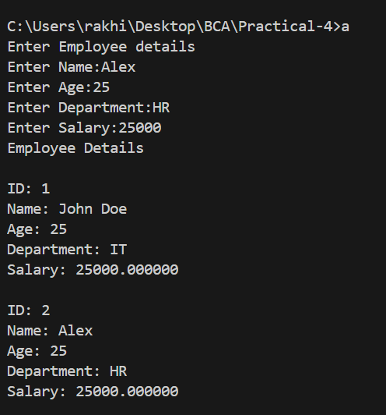

2) Create a structure book with book title, author, publication, and price. Read data of 3 books and display.
Program:-
#include<stdio.h>
struct Book{
char Book_Title[20];
char Book_Author[20];
char Book_Publication[20];
int Book_Price;
};
void main(){
struct Book Book[3];

printf("\nEnter Book details ");

for (int i = 0; i < 3; i++)
{
printf("\n\nEnter details for Book %d\n",i+1);
printf("Title: ");
fgets(Book[i].Book_Title,sizeof(Book[i].Book_Title), stdin);
printf("Author Name: ");
fgets(Book[i].Book_Author,sizeof(Book[i].Book_Author), stdin);
printf("Publication: ");
fgets(Book[i].Book_Publication,sizeof(Book[i].Book_Publication), stdin);
printf("Price: ");
scanf("%d",&Book[i].Book_Price);
getchar();
}

printf("\nBook Details\n");

for (int i = 0; i < 3; i++)
{
printf("\nBook %d\n",i+1);
printf("Title: %s\n",Book[i].Book_Title);
printf("Author Name: %s\n",Book[i].Book_Author);
printf("Publication: %s\n", Book[i].Book_Publication);
printf("Price: %d\n",Book[i].Book_Price);
printf("\n");
}

}

Output:-

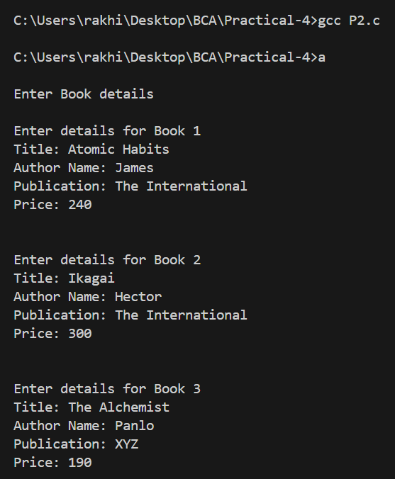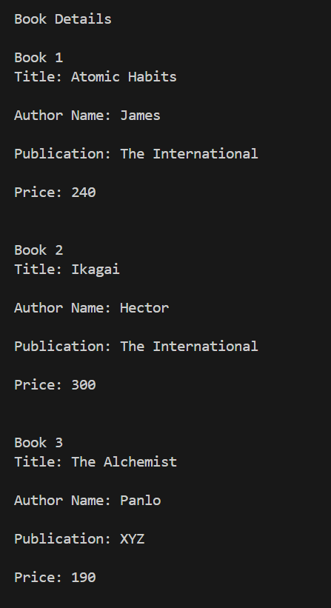

3) Demonstrate difference between Structure and Union.
Program:-
#include<stdio.h>
#include<string.h>
struct Student
{
int roll;
char name[30];
float marks;
};
union Employee
{
int id;
char name[30];
float salary;
};
void main(){
struct Student s1;
s1.roll=121;
strcpy(s1.name,"John");
s1.marks=45.5;

union Employee e1;
e1.id=201;
strcpy(e1.name,"Alex");
e1.salary=25000;

printf("\nStudent Details(Structure)");
printf("\nRoll: %d\nName: %s\nMarks: %f",s1.roll,s1.name,s1.marks);

printf("\n\nEmployee Details(Union)");
printf("\nID: %d(Prints Garbage value)\nName: %s(Prints Garbage value)\nSalary: %f\n",e1.id,e1.name,e1.salary);
}

Output:-

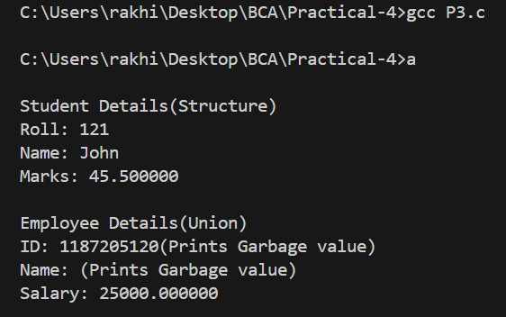

4) Demonstrate Nested Structure.
Program:-
#include<stdio.h>
#include<string.h>
struct Address{
char City[20];
char State[20];
int pincode;
};
struct Result{
int sem;
float spi;
};
struct Student
{
int roll;
char name[30];
struct Address a[2];
struct Result result;

};
void main(){
struct Student s1={121,"John Doe",{{"Rajkot","Gujarat",360004},{"Morbi","Gujarat",363650}},{3,9.5}};
printf("Roll: %d\nName: %s\nAddress 1: %s, %s, %d\nAddress 2: %s, %s, %d\nResult: Sem: %d, SPI: %f",s1.roll,s1.name,s1.a[0].City,
s1.a[0].State,s1.a[0].pincode, s1.a[1].City,
s1.a[1].State,s1.a[1].pincode, s1.result.sem,s1.result.spi);
}

Output:-

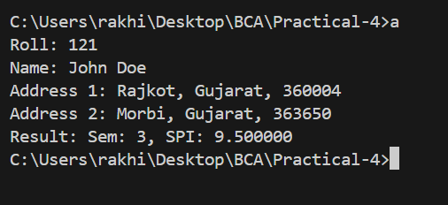

5) Add two distances in feet and inches using structure.
Program:-
#include<stdio.h>

struct Distance
{
int feet;
int inches;
};

struct Distance addDistance(struct Distance,struct Distance);

void main(){
struct Distance d1,d2,d3;
printf("Enter Feet and Inches for first distance respectively:");
scanf("%d %d",&d1.feet,&d1.inches);
printf("Enter Feet and Inches for second distance respectively:");
scanf("%d %d",&d2.feet,&d2.inches);
d3=addDistance(d1,d2);
printf("Added Distance\nFeet: %d\nInches: %d",d3.feet,d3.inches);
}

struct Distance addDistance(struct Distance d1,struct Distance d2){
struct Distance result;
result.feet=d1.feet+d2.feet;
result.inches=d1.inches+d2.inches;
if (result.inches>=12)
{
result.feet+=result.inches/12;
result.inches=result.inches%12;
}
return result;
}

Output:-
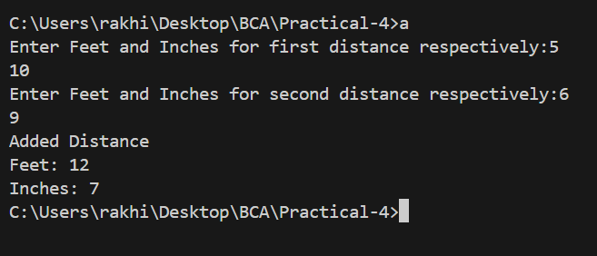

6) Add two times hh, mm and ss using structure.
Program:-
#include<stdio.h>

struct Time
{
int hours;
int minutes;
int seconds;
};

struct Time addTime(struct Time,struct Time);

void main(){
struct Time t1,t2,t3;
printf("Enter hours, minutes and seconds for first time respectively:");
scanf("%d %d %d",&t1.hours,&t1.minutes,&t1.seconds);
printf("Enter hours, minutes and seconds for first time respectively:");
scanf("%d %d %d",&t2.hours,&t2.minutes,&t2.seconds);
printf("\nEntered Times:");
printf("\n%d:%d:%d",t1.hours,t1.minutes,t1.seconds);
printf("\n%d:%d:%d\n",t2.hours,t2.minutes,t2.seconds);
t3=addTime(t1,t2);
printf("\nAdded Time\nHours: %d\nMinutes: %d\nSeconds: %d",t3.hours,t3.minutes,t3.seconds);
printf("\n%d:%d:%d",t3.hours,t3.minutes,t3.seconds);
}

struct Time addTime(struct Time t1,struct Time t2){
struct Time result;
result.hours=t1.hours+t2.hours;
result.minutes=t1.minutes+t2.minutes;
result.seconds=t1.seconds+t2.seconds;
if (result.seconds>=60)
{
result.minutes+=result.seconds/60;
result.seconds=result.seconds%60;
}
if (result.minutes>=60)
{
result.hours+=result.minutes/60;
result.minutes=result.minutes%60;
}
return result;
}

Output:-
